Conference project specification and plan

# Product Overview

Our idea is to collect attendance figures for the entire conference when users collect their name badges and attendance figures for individual sessions. We are representing the amount of people as bees that fly out of a hive and fly around for a set amount of time before fading out for the attendance of the conference. Otherwise, the bees fly out of the hive and they land on a set session flower and then they fade out depending on which button is pressed.

# Product Design (Layout etc)

Attendance for the entire conference

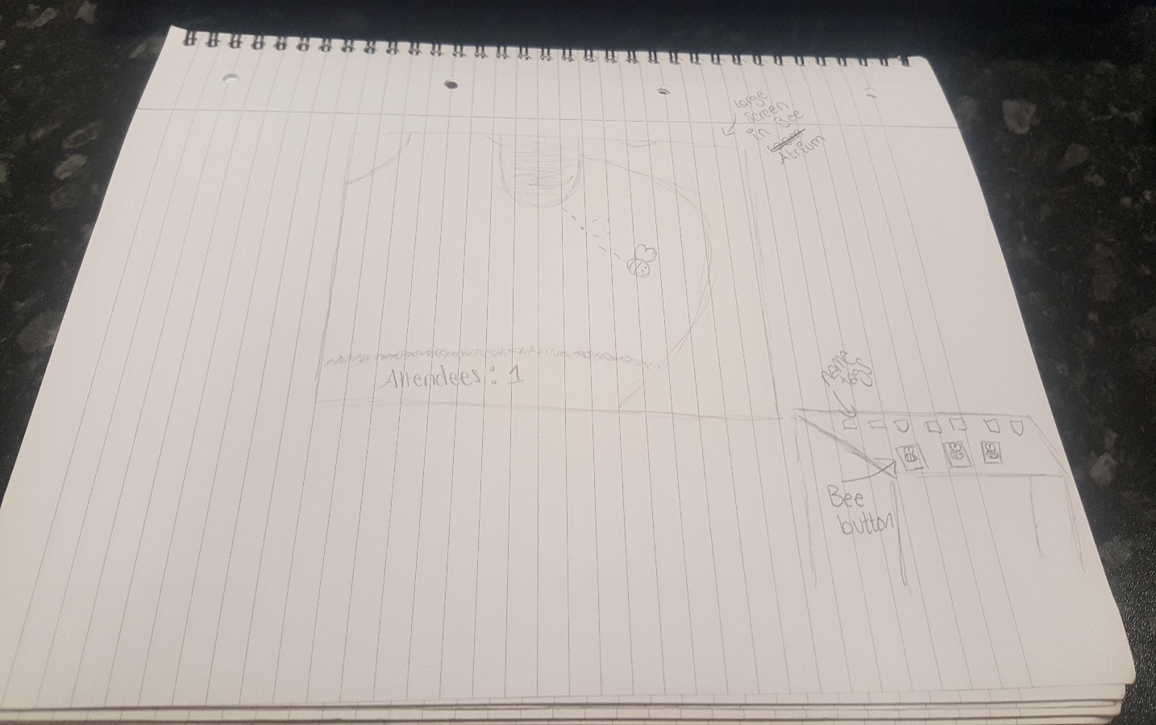

Attendance for each session

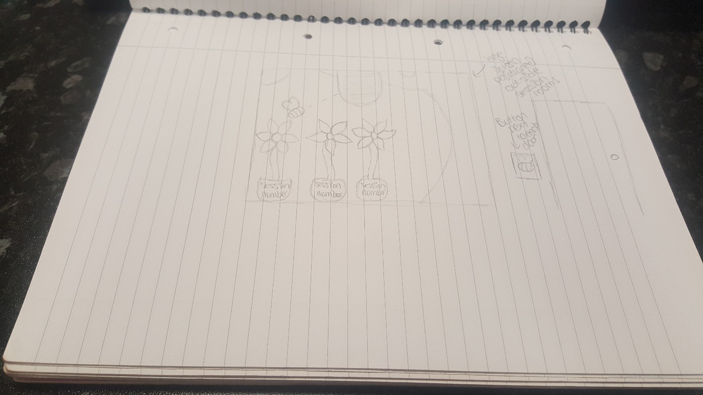

# Equipment List

1 big screen to display the bee animation

8 tablet/phone screens to display the bee button

# Digital Technical Support Requirements

Need someone to change the animation on the big screen downstairs from the entire conference animation to sessions animation.